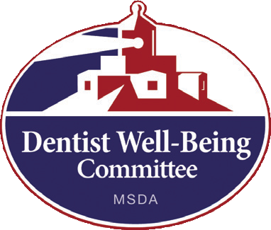
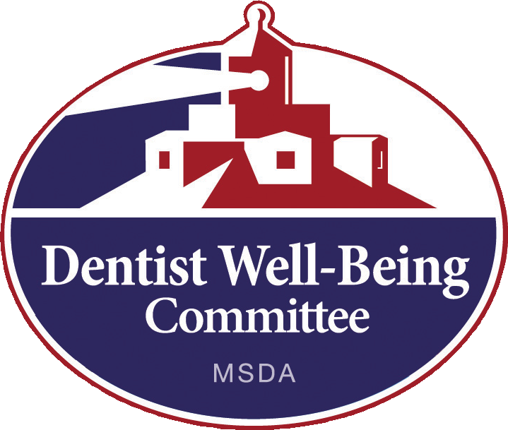
State Board of Dental Examiners
The Committee receives referrals from the State Board of Dental Examiners and is requested to evaluate, refer to treatment and monitor certain cases. In these instances, the case is not completely confidential due to being a Board referral, rather than a self-referral.
However, the Committee still serves a very important function in terms of advocating
for the dentist who
complies with the
treatment agreement
and monitoring
requirements.

Contact Information
For further information, contact Robert White (Clinical Coordinator) at 410-328-8549 or toll free at 1-888-233-9044.
Any correspondence can be directed to Robert White at
410 W. Redwood Street,
“Recovery taught me
to take responsibility for myself. I don’t act impulsively and
I appreciate life today. I am grateful for the things I have today. It took a lot of pain and loss before I could learn to appreciate all
aspects of my life.”
Suite 560, Baltimore, MD 21201.
The fax number is 410-328-1132. Visit us on the web at www.dentistwellbeing.com
Dentist Well-Being Committee
A program for assisting dentists and their families with personal problems
www.dentistwellbeing.com
1-888-233-9044

PRSRT STD
U.S. Postage PAID
Permit 1220
Columbia, MD
Dentist Well-Being Committee
6410 Dobbin Road
Columbia, MD 21045

Purpose
The Committee assists dentists and their families who may be experiencing personal problems. The committee has helped many dentists over the years with problems such as stress, alcohol and drug use, depression, and other problems that may cause impairment in their lives.

Confidentiality
This program
was awarded the Golden Apple for Excellence in Dentist Well Being Activities
by the American Dental Association (ADA). This is a national award
that is presented to
only one program per year.
The Committee provides a confidential non- disciplinary avenue
for dentists to seek appropriate help for problems. Referrals are completely confidential.
Any dentist who seeks help through the Committee can be
assured their information will be held in the strictest confidence.

Advocacy
When a dentist enters into a treatment agreement with the Committee and remains in compliance with all aspects of the agreement, the Committee is able
to provide written and verbal testimony and support of the dentist whenever it is needed. The most common example is when the dentist needs advocacy with regard to licensure issues. In other cases, the Committee has advocated with the court system, employers, malpractice carriers, and other institutions.

Committee Members
The Dentist Well-Being Committee consists of concerned dentists who wish to help their peers to resolve problems and maintain their ability to practice.
A Clinical Coordinator is in charge of the initial contact, evaluation, referral and monitoring.
Robert Miller, DDS, Chairman
410-535-4050, rgmillerhjf@hotmail.com
Robert White, LCPC, Clinical Coordinator
410-328-8549, rwhite@psych.umaryland.edu
Michael Anderson, DDS
301-797-6841
Lenora Caldwell, DDS
410-206-6434
Greg Hutton, DDS
301-698-9552
Brian Muhler, DDS
410-252-2424
Jerry Yeoumans, DDS
410-321-1133

Advisory Member
Hal Crossley, DDS
Norbert Myslinski, PhD
Dental School Liaison

Is the Process Punitive?
NO - The Dentist Well-Being Committee acts as an advocate for the dentist with the State Board of Dental Examiners, insurance companies, and law enforcement agencies, as long as the dentist is compliant with treatment.

What Happens After a Referral?
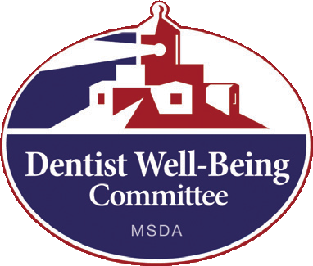
Family members, employees, associates or friends concerned about a dentist often contact the Dentist Well-Being Committee. Many dentists are self-referred. The Committee first determines if the dentist actually has a problem. The dentist is contacted and
“For me, getting
into recovery is changing and improving my life in significant ways.
The most impressive
change was the choices I now have in managing and coping with life experiences and with my feelings.”
urged to meet the Clinical Coordinator. If there is a problem then the dentist is referred for an evaluation.
If treatment is recommended then a treatment agreement is drawn up between the dentist and the Committee.

Is the Information Given to the
Committee Confidential?
All information held by the Dentist Well-Being Committee is considered strictly confidential. Records are kept by the Clinical Coordinator and are not at the offices of the Maryland State Dental Association. With the exception of those cases that are referred to the Committee by the State Board or those considered to be a danger to themselves or others, no information is released without the dentist’s written consent.

Family Questions
The Committee welcomes calls and questions from family members who may be concerned about a dentist. We will work confidentially to provide assistance, support and guidance about the best way to intervene and assist a dentist with a problem.

